**CSC 430 – Database Management Systems**

Exam 2 - PRACTICE

Name:

Instructions:

* Put your name in the appropriate place at the top of this page;
* Do not use red ink;
* **Closed books and notes;**
* **No electronic devices are allowed; This includes calculators.**
* You will only receive points for a question if you attempt to answer it;
* For full credit, list all formulas that provide the basis for calculations and show all work;
* If you aren't clear about a question, state your assumptions first followed by your answer;
* When finished with the exam read and sign the pledge at the bottom of this page.

Good luck!

# “On my honor as a Louisiana Tech student, I have neither given nor received unauthorized assistance on this academic work.”

Student signature

**Section A: Multiple-choice questions.**

Please, circle a single correct option.

1. Select correct statement(s):
   1. Data Definition Language (DDL) includes commands such as CREATE and DROP.
   2. Data Definition Language (DDL) includes commands such as SELECT and INSERT.
   3. Data Manipulation Language (DML) includes commands such as ALTER and TRUNCATE.
   4. Data Manipulation Language (DML) includes commands such as UPDATE and DELETE.
   5. Only a, b.
   6. Only b, c.
   7. Only c, d.
   8. Only a, d.
2. Select correct statement(s) about functional dependencies:
   1. They are not needed for the relation normalization process.
   2. They are determined by the interpretation of the mini-world.
   3. Given the state of a database, we can see if a FD is violated.
   4. All of the above.
   5. Only a, b.
   6. Only b, c.
3. Select correct statement(s) about the goal(s) of the normalization process:
   1. A goal is to minimize data anomalies from occuring.
   2. A goal is to make database overly complicated.
   3. A goal is to preserve functional dependencies.
   4. A goal is to maximize the number of prime attributes.
   5. All of the above.
   6. Only a, c.
   7. Only b, c.
   8. Only a, b.
4. Select correct statement(s):
   1. Primary indexes are used when data file is ordered by primary key attributes.
   2. Clustering index is used when data file is ordered by a non-key attribute.
   3. Secondary index is defined over non-ordering attributes of a record.
   4. All of the above.
   5. None of the above.
   6. Only a, b, c.
   7. Only a, b, d.

**Section B: Open-ended questions.**

To get full points provide complete answer, be specific and concise.

1. Show the full syntax of a trigger.
2. Show the full syntax of a function.
3. What are the differences between a trigger, view, stored procedure and a function?
4. State the condition(s) for each normal form to be satisfied.

First normal form:

Second normal form:

Third normal form:

**Section C: Practical questions.**

To get full points show all work, provide all formulas and calculations.

1. Write a query to retrieve Ssn of all employees who worked on project number 2 for at least 15 hours. For full points - use aliasing when joining tables and rename attribute of the resulting relation to “Employee_SSN”. Database state is provided for you on a separate page.
2. Write a function to get the sum of all hours across all projects and the count of all projects worked on by a particular department number (given as parameter). You must give correct characteristics to the function for full credit. Database state is provided for you on a separate page.
3. Write a trigger that would remove all projects (from the project table) with the corresponding department number when a row is deleted from the department table. Database state is provided for you on a separate page.
4. Define which of the provided functional dependencies may hold for the following relation. If the dependency cannot hold – justify your answer, by specifying at least one tuple that causes the violation.

|  |  |  |  |
| --- | --- | --- | --- |
| **OEM** | **Model** | **Distributor** | **Price** |
| Dell | Optiplex | Office Depot | $1,200 |
| Dell | Optiplex | Dell.com | $1,200 |
| HP | Z Book | hp.com | $2,000 |
| HP | Y Book | Bob in a parking lot | $350 |
| Lenovo | Thinkpad | lenovo.com | $10,000 |
| Lenovo | Ideapad | lenovo.com | $1,500 |

1. OEM -> Model
2. OEM -> Price
3. {OEM, Model} -> Price
4. Price -> Model
5. Price -> Distributor
6. What is the highest normal form of the following relation? To support your answer, specify which functional dependencies violate which of the normal forms.

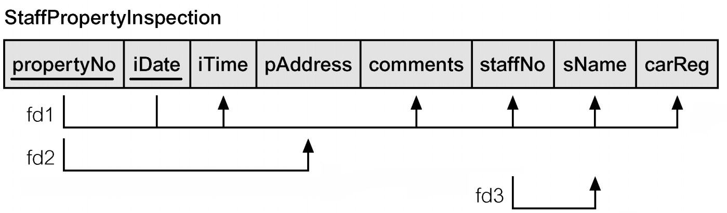

1. Consider a disk with a block size B = 2048 bytes. Suppose file has r = 8,000 DEPARTMENT records of fixed length. Each record has following attributes: Dname (25 bytes), Dnumber (4 bytes), Mgr_ssn (9 bytes), Mgr_start_date (10 bytes). In addition, suppose the file is sorted on Dnumber primary key attribute. Assuming an unspanned organization, calculate the record size **R**, the size of file ordering key **V**, blocking factor **bfr**, and the number of file blocks **b.** Show all formulas (with variable names), all calculations (with values plugged in), and give final numeric answers for each (i.e. don't leave any final answer as a math equation).

